# Text Symbols in Report

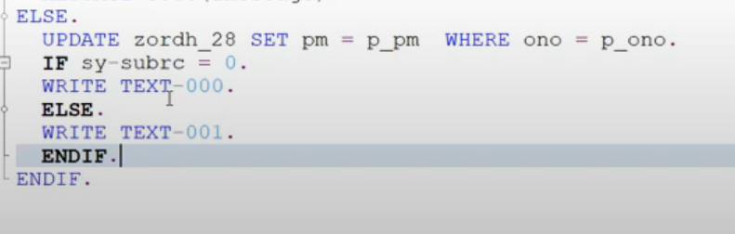

Figure Creating text symbols.

## Creating text symbols

Give the number in the code itself, double-click on the number it will redirect to another screen.

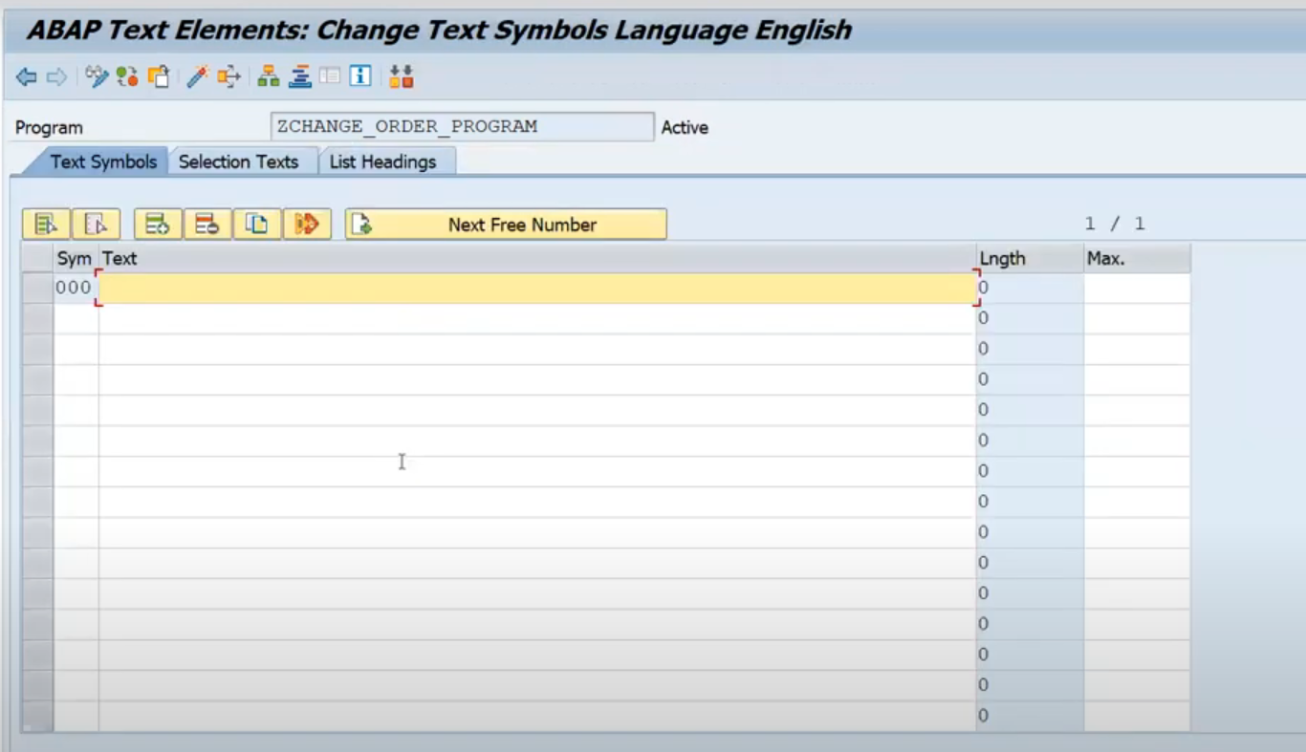

Figure Screen that will pop after double clicking on the number.

## Alternatively, to create text symbols.

Go to-> Text Elements -> Text Symbols.

The same screen will pop up.

## Give the description.

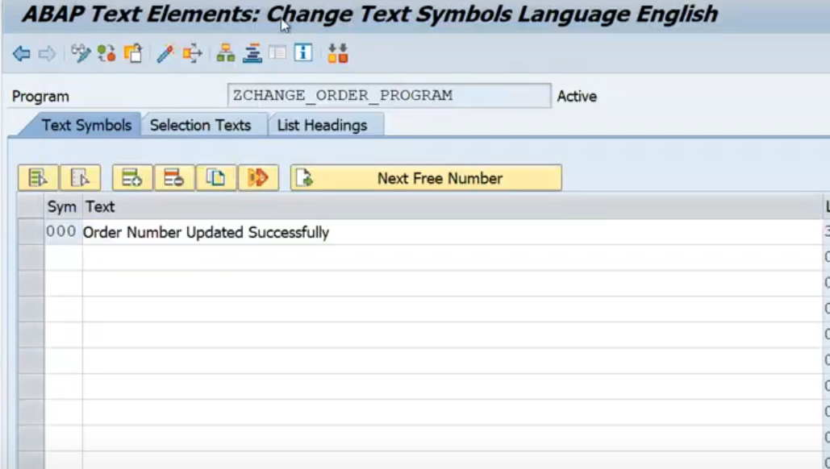

Figure Add the text for the text symbol.